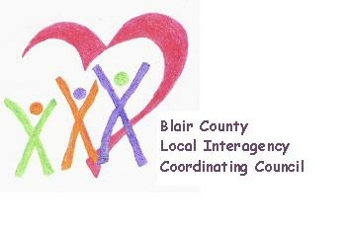

Local Interagency Coordinating Council

Agenda for September 16, 2021
Zoom meeting
9:30 am

- Welcome and Introductions
- Review May meeting minutes
- Policy and Procedure
  - Sunshine Law changes
- Child Find/Service Delivery
- Membership
- Education and Training
  - IMH-EI COP
- Agency updates
- Other

Next meeting: November 18, 2021 at 9:30 am

