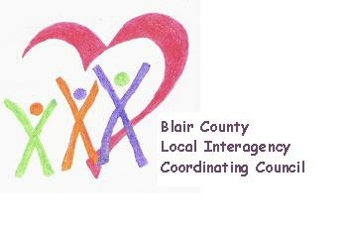

Local Interagency Coordinating Council

Agenda for November 18, 2021
Zoom meeting
9:30 am

- Welcome and Introductions
- Review September meeting minutes
- Policy and Procedure
- Child Find/Service Delivery
- Membership
- Education and Training
- Agency updates
- Other
  - State Performance Plan input

Next meeting: January 20, 2022 at 9:30 am

