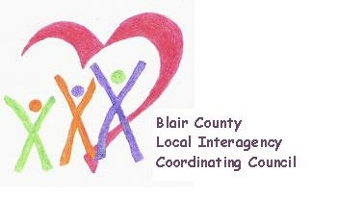

Local Interagency Coordinating Council

Agenda for January 20, 2022
Zoom meeting
9:30 am

- Welcome and Introductions
- Review November meeting minutes
- Blair County’s Care for Kids and Families Resource Guide
- Policy and Procedure
- Child Find/Service Delivery
  - Child Find Day at Delgrosso’s Sponsored by IU8
- Membership
- Education and Training
  - EITA Social Emotional training events through September
- Agency updates
- Other

Next meeting: March 17, 2022 at 9:30 am

