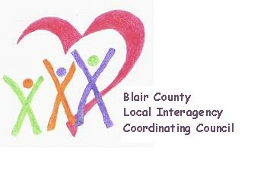

Local Interagency Coordinating Council

Agenda for March 16, 2023
Zoom meeting
9:30 am

- Welcome and Introductions
- Review January meeting minutes
- Policy and Procedure
- Child Find/Service Delivery
  - Child Find Day at Delgrosso’s sponsored by IU8
  - Child Find Posters
- Membership
- Education and Training
  - Blair EI-IMH COP update
- Agency updates
- Other
  - EI Family Survey

Next meeting: May 18, 2023 at 9:30 am

