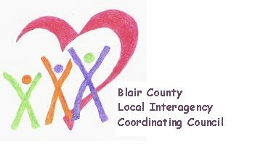

Local Interagency Coordinating Council

Agenda for May 18, 2023
Zoom meeting
9:30 am

- Welcome and Introductions
- Review March meeting minutes
- Presentation: Coleen Heim - Healthy Blair County Coalition (send flyer with meeting notice)
- Policy and Procedure
- Child Find/Service Delivery
- Membership
- Education and Training
- Agency updates
- Other

Next meeting: 2023-2024 meeting schedule TBD

