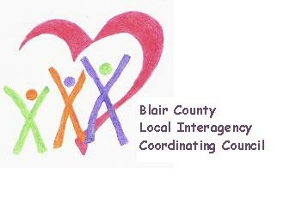

Local Interagency Coordinating Council

Agenda for September 21, 2023
Zoom meeting
9:30 am

- Welcome and Introductions
- Review May meeting minutes
- Presentation: Healthy Families America - Amber Brick, Kids First Affiliated
- Policy and Procedure
- Child Find/Service Delivery
- Membership
- Education and Training
- Agency updates
- Other

Next meeting: November 16, 2023 at 9:30 am.

