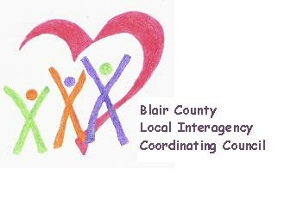

Local Interagency Coordinating Council

Agenda for January 18, 2024
Zoom meeting
9:30 am

- Welcome and Introductions
- Review November meeting minutes
- Policy and Procedure
- Child Find/Service Delivery
- Membership
- Education and Training
- Healthy Families America Program– Amber Brick, Kids First Affiliated
  - Enrollment numbers
  - Outreach strategies
  - Implementation plan updates
  - Progress on quality improvement plan
- Agency updates
- Other
Next meeting: March 21, 2024 at 9:30 am.

