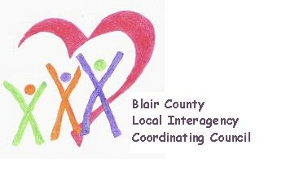

Local Interagency Coordinating Council

Agenda for March 21, 2024
Zoom meeting
9:30 am

- Welcome and Introductions
- Review January meeting minutes
- Policy and Procedure
- Child Find/Service Delivery
- Membership
- Education and Training
- Healthy Families America Program updates
- Agency updates
- Other
Next meeting: May 16, 2024 at 9:30 am.

