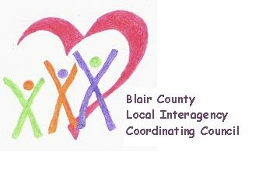

Local Interagency Coordinating Council

Agenda for May 16, 2024
Zoom meeting
9:30 am

- Welcome and Introductions
- Review March meeting minutes
- Policy and Procedure
- Child Find/Service Delivery
- Membership
- Education and Training
- Agency updates
- Other
Next meeting: 2024-2025 meeting schedule TBD

